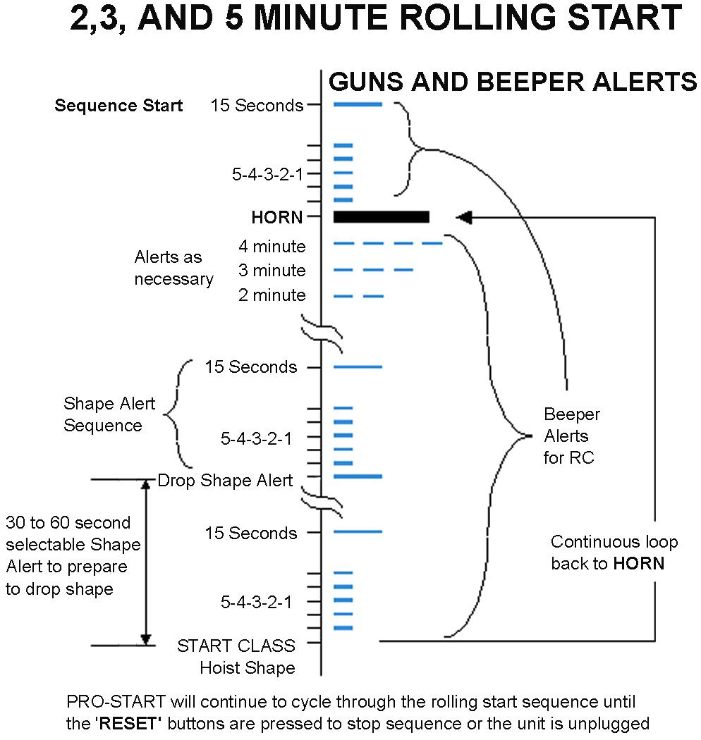
PHC
SYSTEMS
www.phcsystems.com
Depress and release to determine the sequence you are in.
Depress and hold to cycle through the sequences. Release when you are at the desired sequence.
Depress and release to determine the seconds for shape alert.
Depress and hold to cycle through the shape alert values
Release when you are at the desired value.
Depress and release to start the selected sequence.
Depress at any time to sound the horn.
Sequences in progress are not affected.
Depress ‘Sequence Select’ and ‘Shape Alert Select’ together to reset any sequence in progress.
BEEPER RESPONSE
MANUAL
HORN
SHAPE ALERT
SELECT

SEQUENCE
SELECT
SEQUENCE
START
REGATTA PRO-START
RESET
1 minute Dinghy sequence
2 minute Dinghy sequence
3 minute Apx Q Dinghy sequence
5 minute Rule 26 sequence
Match Race AC sequence
2 minute rolling sequence
3 minute rolling sequence
5 minute (pre 2001) rolling sequence

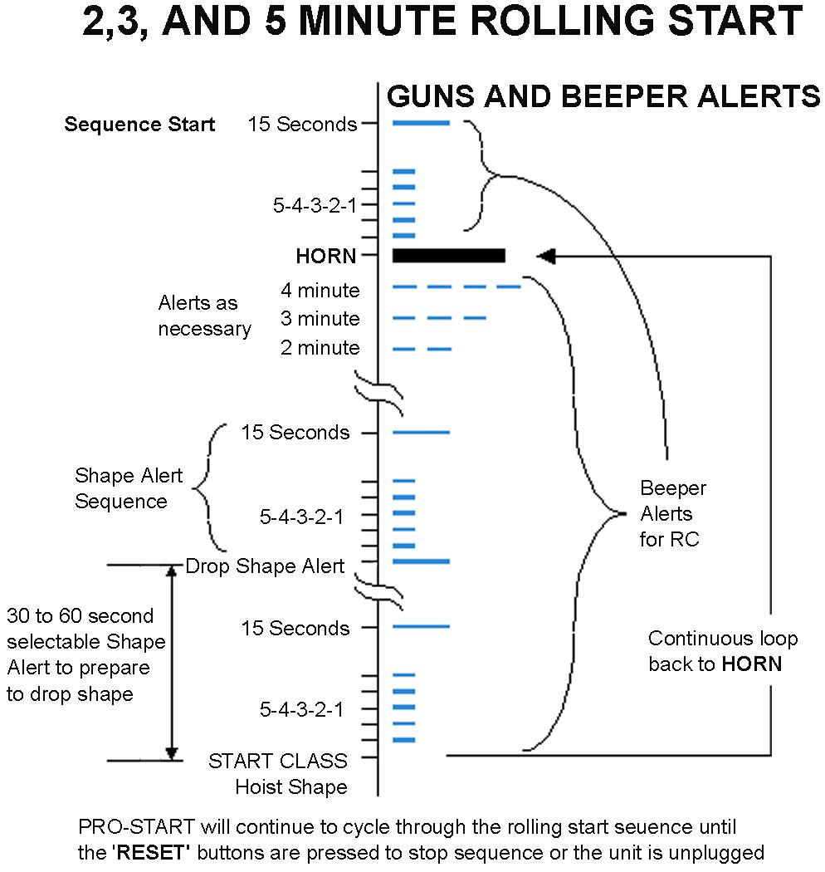

●●
No shape alert
10 second shape alert
20 second shape alert
30 second shape alert
40 second shape alert
50 second shape alert
60 second shape alert

QUICKSTART PROCEDURE  - Turn the “ON/OFF” switch on the battery pack to “ON”,  Verify that the beeper and horn chirp  - Set Sequence Select for desired starting sequence.  - Set Shape Alert Select for desired ‘Alert’ time.  - Depress Sequence Start  IMPORTANT  - Keep the battery charged. A battery left partially discharged will lose energy over time due to sulphation. . | Shape Alert Button
  This button has different meanings for each sequence as follows:
  1, 2, & 3 min Dinghy | Attention signal tens of seconds prior to first gun
  5 Minute | Attention signal tens of seconds prior to first gun
  Match Race | Warning signal minutes prior to Prepretaratory gun
  2, 3,& 5 min Rolling | Shape alert tens of seconds prior to start gun

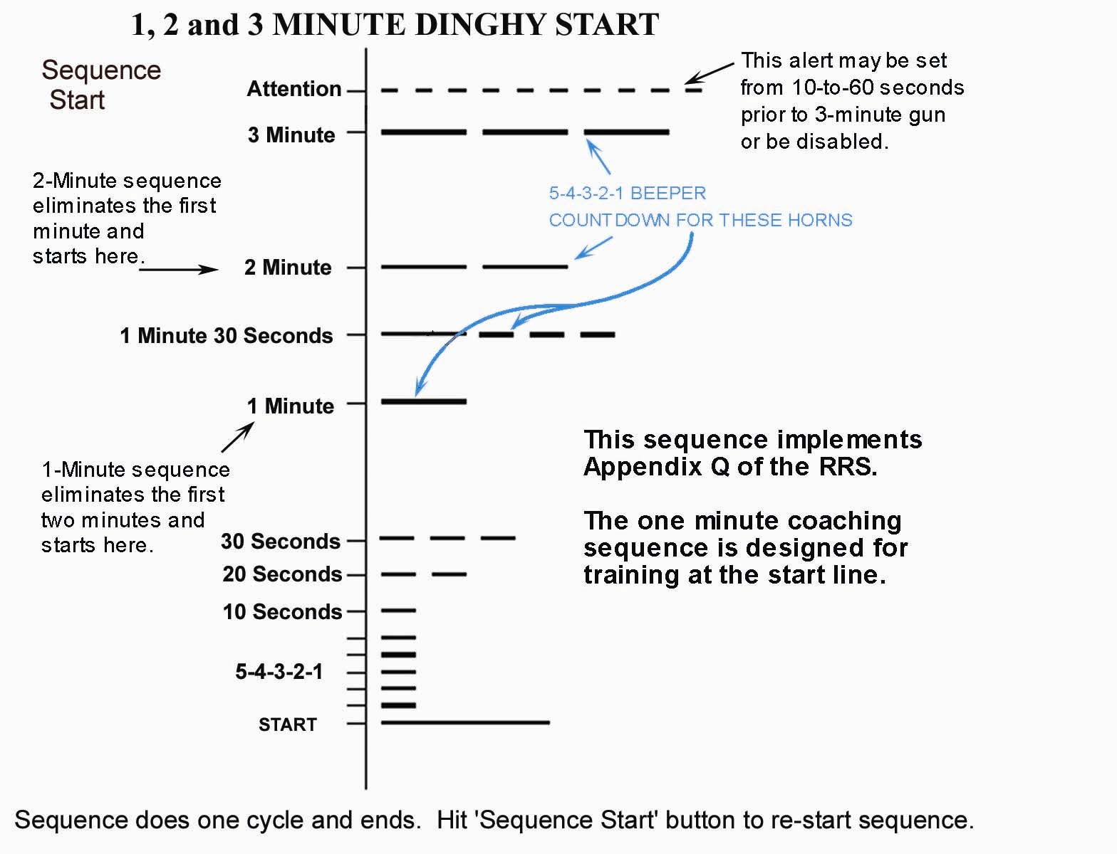 | 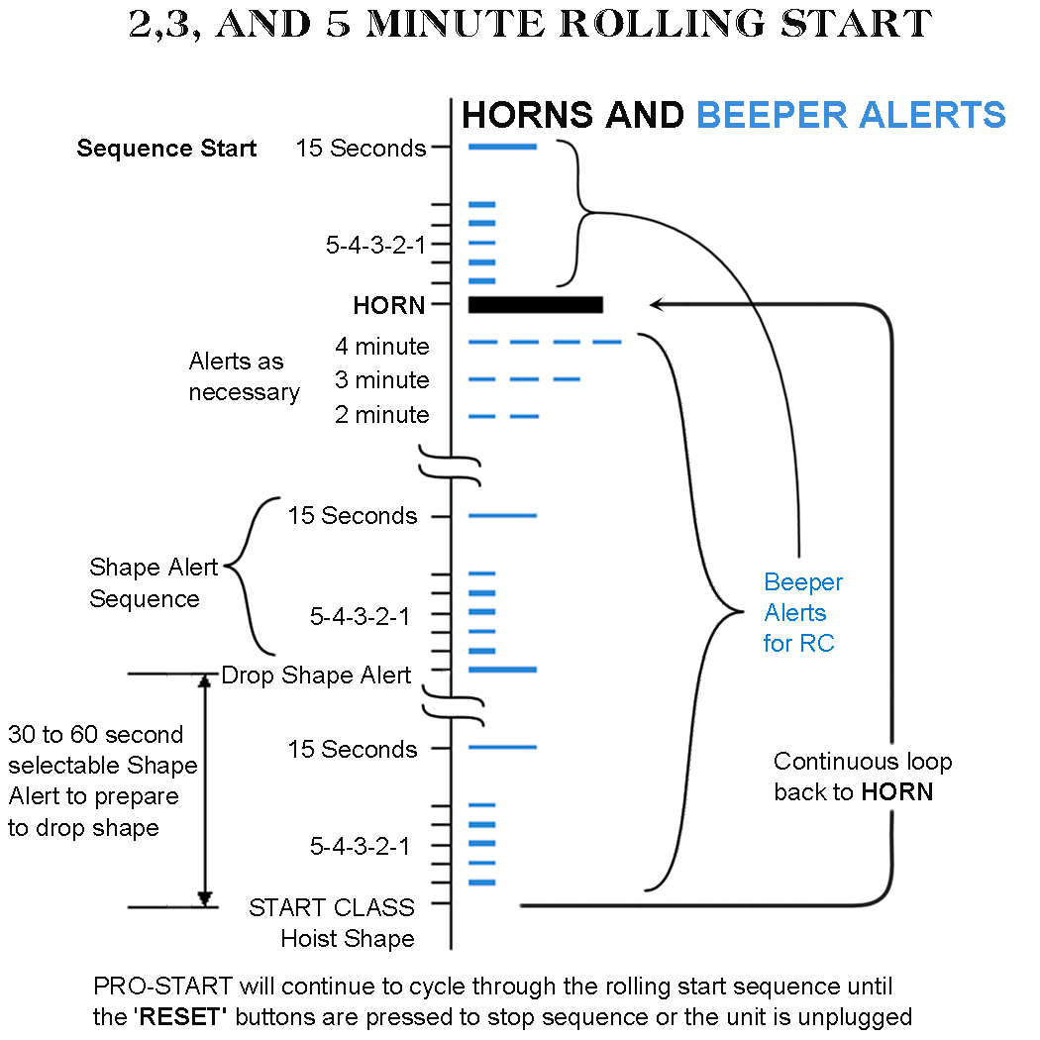
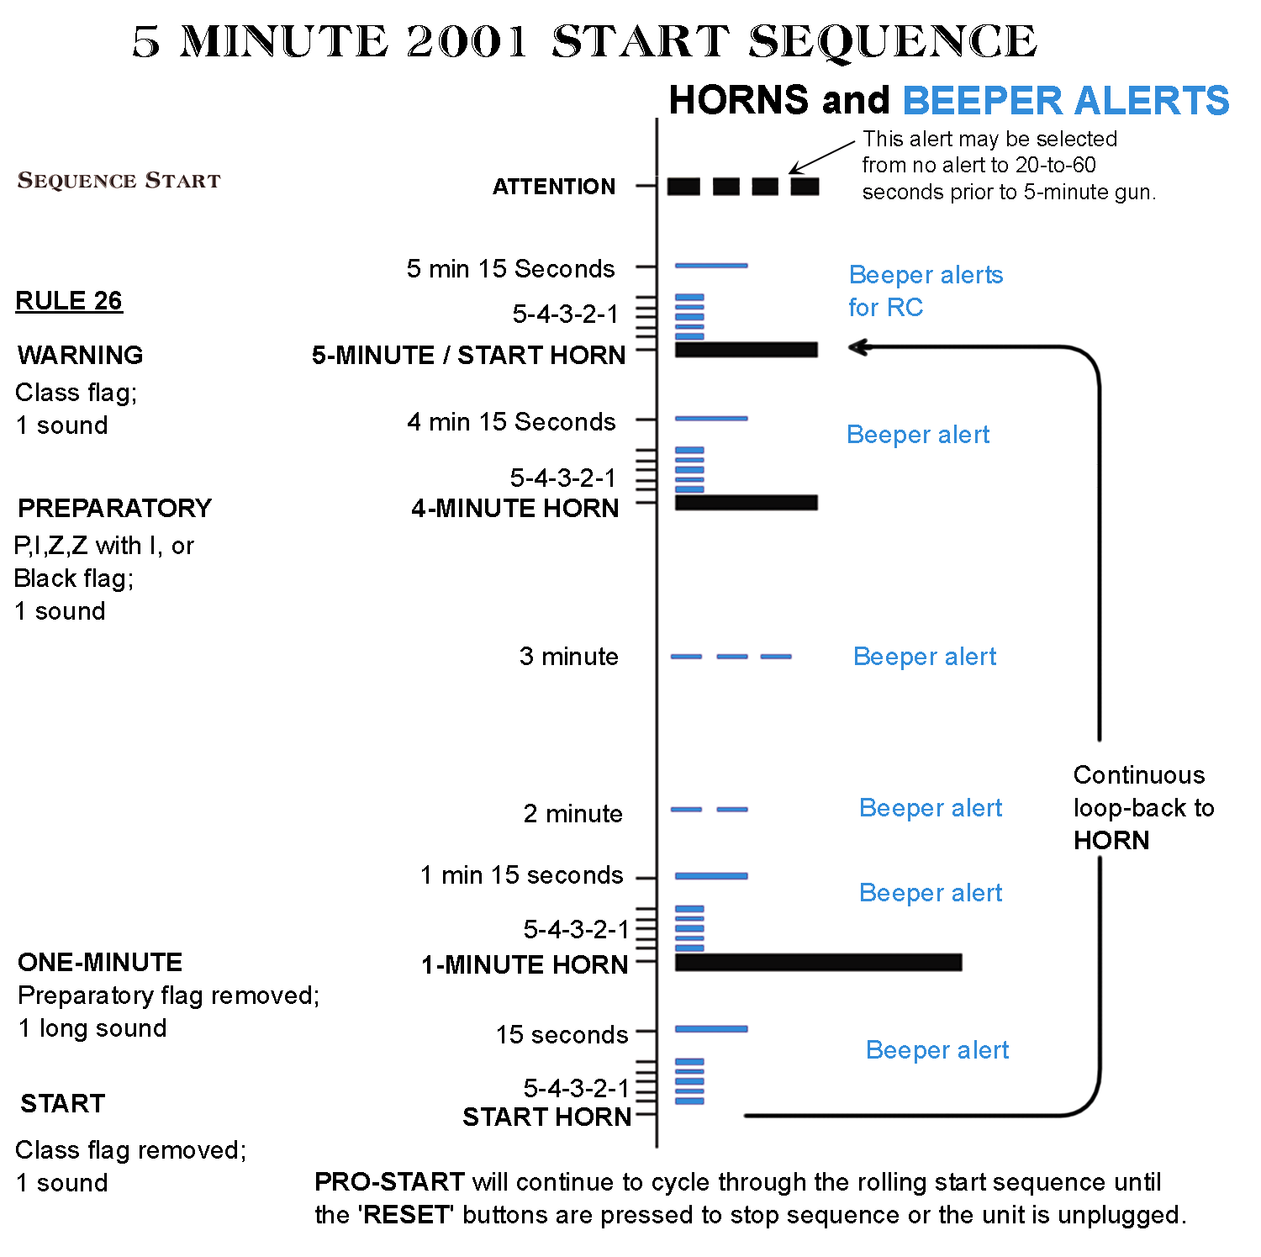
 | 

